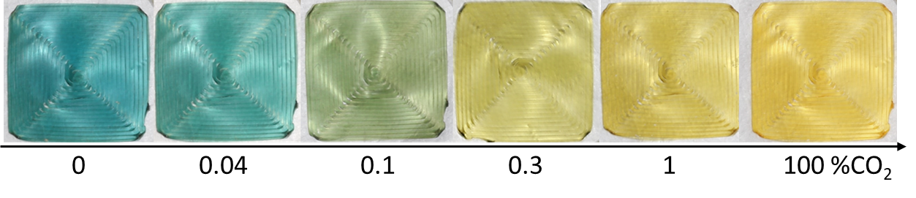



#44291d

#4a2c1f





#392218

#3e261a





#2d1b13

#331f15